Chapter 18, Solution 32.

(a) Since 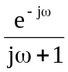 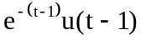
and 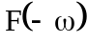 f(-t)
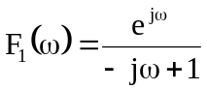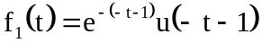
f₁(t) = 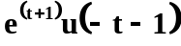

(b) From Section 17.3,

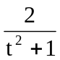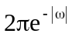
If 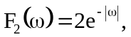 then
f₂(t) = 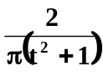

- By partial fractions
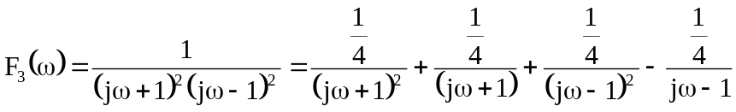

Hence 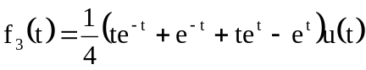
= 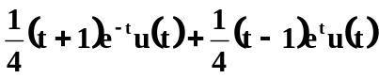

(d)   